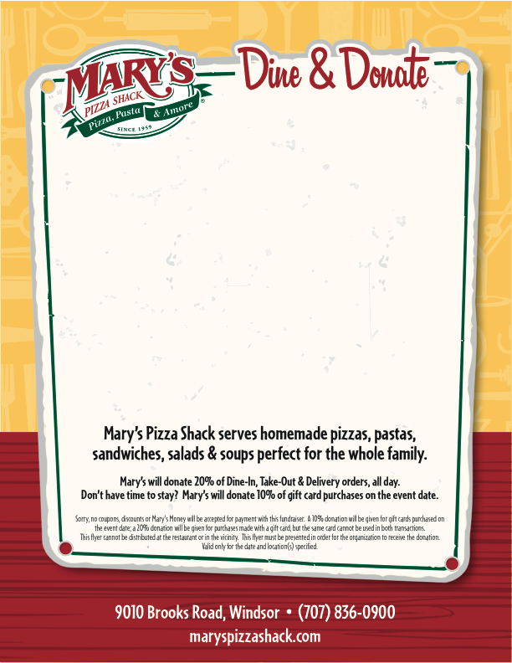
Please join Mary’s Pizza Shack in supporting
STEPHANIE BETTIGA TRUST FUND
at a Dine & Donate Fundraiser on
TUESDAY, JULY 27TH, 2010!

Bring this flyer to the Mary’s Pizza Shack in Windsor and support the Stephanie Bettiga Trust Fund. Twenty percent of your purchase will be donated to the trust fund when you present this flyer with your order.

